To access the new Engage system, browse to the following address: https://engage.imtef.org. You will be presented with the following login page.......
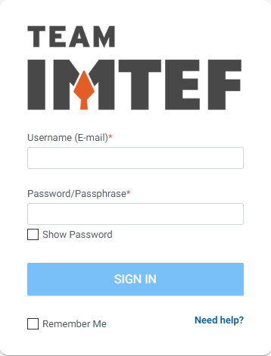
For each apprentice, your username is equal to the primary email address that you have on file with the Local. Your initial password will be the same password that you used to log into the old Apprentice Portal.
The first time that you log in, you will be prompted to set a new password. You will also be prompted to set three security questions and related answers.
Once you are fully logged in, you will land on the Engage "Wall". This page will display regularly updated announcements and news articles posted by the Local staff:

To record new time entries, click on "My Account" in the upper left-hand corner and choose "My Time" from the menu that appears:
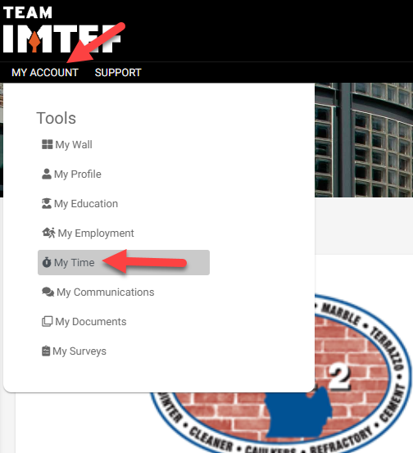
The new timecard entry window will appear. Choose the type of time, OJL, under "Facet Type" and choose the month the timecard is for under "Period".
Next, under "Add New Entry", choose "Entire Period" as the interval and choose your contractor from the "Employer" drop-down list. Enter your manager's name and enter the number of hours you wish to record under the "Hours" field. Finally, from the "Skill" drop-down list, choose the skillset to which the hours you are recording pertain to. Once done, click the "Add Entry" button to record the entry. Engage will then add a new row to your pending timecard for the hours and skill that you specified.
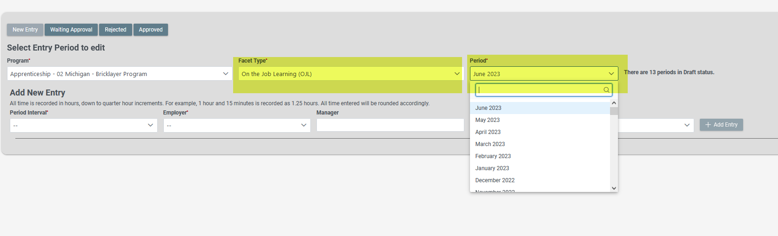
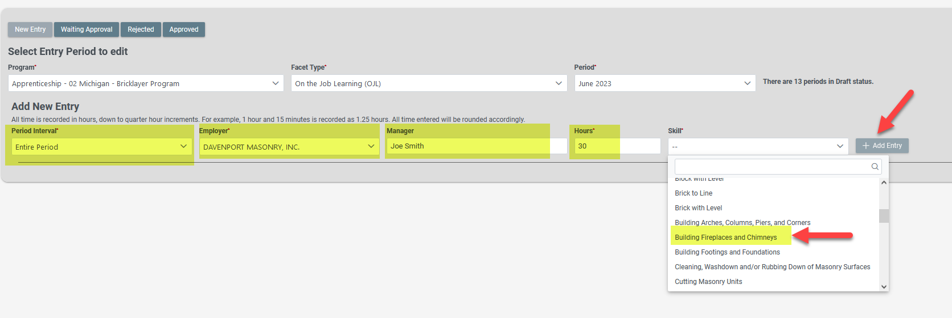
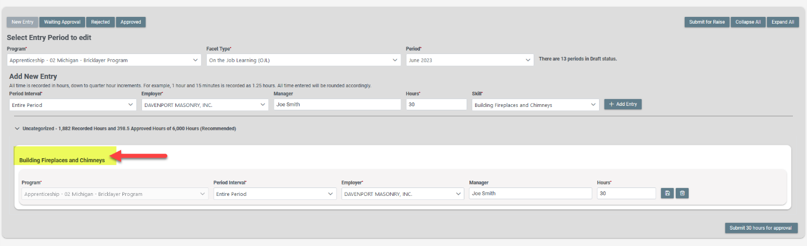
To add additional activities to the timecard, simply go back up to "Add New Entry" and specify the time and information for the additional skill you wish to add. Once done, click the "Add Entry" button to add the new row to the pending timecard.
You can edit any of the existing entries on your timecard. For example, if you need to change the number of hours you entered for a skill, simply enter the updated figure in the "Hours" field. Make sure to click the "Save" icon on the right row you edited to commit the change you made. If you find that you need to remove any entries that you previously made on the timecard, simply click the "Delete" icon on the far right-hand side of the row you wish to remove.
Once you are done adding all of the entries for your timecard for the month, you can submit it for approval by clicking the "Submit for Approval" button in the lower right-hand corner. Once you have submitted a timecard for approval, you can no longer make any changes to it.
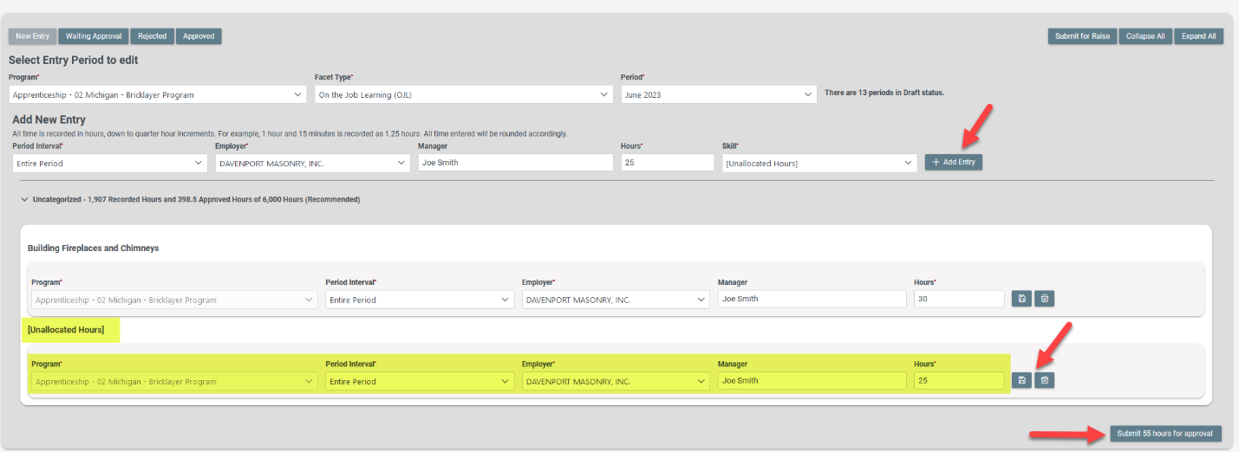
You can view all timecards that you have submitted for approval via the "Waiting Approval" button at the top of the timecard window.
The "Rejected" button will list any timecards you submitted that the training staff did not approve. The "Approved" button will list all of your submitted timecards that have been approved by the training staff.
If you should have any issues at all with submitting your timecards via the new Engage system, please get in touch with the apprenticeship staff, or contact John directly.

